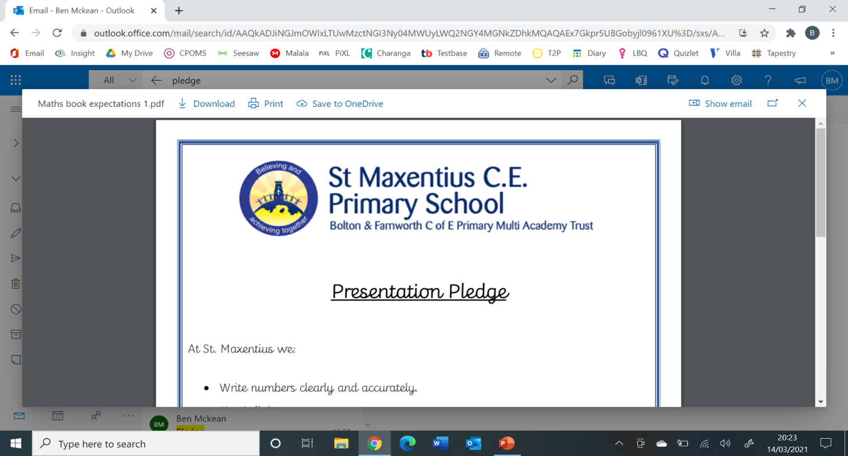St Maxentius CE Primary School Calendar of Events 2024-25

|  |  |
| --- | --- |
| September 2024 | |
| 3rd | Children back to school 8:45am |
| 24th | Individual School Photos |
| 26th | Buddy Service St Maxentius Church – Initiation into role for the Year 5 and Reception Children : 9:15am |
| 25th | Non uniform day for cake donations for McMillan Fundraiser |
| 27th | McMillan Coffee Fundraiser : 3:00pm – 4:00pm in the school hall |
| October 2024 | |
| 3rd | Year 5 lead the KS2 Harvest Service at St Maxentius Church 9:15 am |
| 24th | Afterschool disco – 3:30pm-5:00pm Reception, Y1,Y2,Y3 5:30pm-7:00pm – Y4,5,6, |
| 25th | HALF TERM finish at 3:30pm |
| November 2024 | |
| 5th | Children back to school 8:45am |
| 7th | Y6 lead school Remembrance Service in the hall 9:15am |
| 10th | Remembrance service at St Maxentius Church – Y6 invited to help lead |
| 11th -15th | Anti – Bullying week / Odd socks day |
| 21st | Parents Evening 3:45pm -7:45pm |
| December 2024 | |
| 5th | Rec,Y1,Y2 Christmas event :3:30pm -4:45pm Y3,4,5,6 Christmas movie night 5pm -6:30pm |
| 10th | Reception Nativity performances at 9:30am and 5:30pm |
| 11th | Y1 &Y2 lead Christingle Service in St Maxentius Church – 6:00pm |
| 12th | KS2 Carol Service in St Maxentius Church 9:15am |
| 13th | Christmas Jumper Day |
| 17th | Reception, Y1 &Y2 Christmas parties – 1-3:30pm |
| 18th | Y3 &Y4 Christmas parties – 1-3:30pm |
| 18th | Reception , Y1,Y2 Wiggle Worship in St Maxentius Church 9:15am |
| 19th | Y5 & Y6 Christmas parties – 1-3:30pm |
| 20th | CHRISTMAS HOLIDAY finish at 1:15pm |
| January 2025 | |
| 7th | Children back to school 8:45am |
| February 2025 | |
| 11th | Safer internet day |
| 14th | Valentines day compliments / cards – celebrate our school value of LOVE |
| 14th | HALF TERM finish at 3:30pm |
| 24th | Children back to school at 8:45am |
| March 2025 | |
| 4th | Class Photographs |
| 5th | Y4 Class worship – Shrove Tuesday / Ash Wednesday / Lent in school 9:15am |
| 5th – 7th | Year 6 Residential at Condover Hall |
| 6th | World Book Day |
| 19th -20th | Y5 Bike-ability |
| 27th | Reception Mothers Day Worship – School hall |
| April 2025 | |
| 2nd | Reception, Y1,Y2 Easter Wiggle Worship in the school hall |
| 3rd | Y3,4,5,6 Easter Service in Church – Y3 Lead service |
| 4th | EASTER HOLIDAY finish at 1:15pm |
| 22nd | Children back at school – 8:45am |
| May 2025 | |
| 5th | Bank Holiday – school closed |
| 12th – 15th | Y6 SATS Week |
| 19th – 22nd | Reception Bike-abilty |
| 23rd | HALF TERM finish at 3:30pm |
| June 2025 | |
| 2nd | Children back to school 8:45am |
| 12th | Y1 Class worship – Fathers day |
| 18th | Sports Day : Reception Y1,2 - 9:30am Y3,4,5,6 - 1:30pm (If wet rearranged for the following Wednesdays) |
| July 2025 | |
| 3rd | Y6 Leavers Service at St Maxentius Church – 9:15am |
| 10th | Y6 Show - showings at 9:30am and 4:30pm |
| 17th | Y6 Leavers service in school – 9:15am |
| 18th | SUMMER HOLIDAY finish at 1:15pm |